

**Unpacking and Assembly instructions**

**(Follow the steps on page 2 to unpack the world map)**

**Unpack instructions**

**Dear customer,**

First of we would like to thank you for your order of our wooden world map. We hope that after installation you will enjoy the exclusive eye catcher.

With these instructions we are going to take you step by step, to install the world map as simple as possible.

*Let´s start!!*

Follow these steps to unpack the world map, be gentle:

* On top you will find the template (2 parts), kit, superglue and marking points
* You can lift up the first plate. The parts will fall out, if not, then push them out gently.
* The second plate, you can do the same as the first plate.

Before you continue please check if you have all the necessary parts

* 25 marking points;
* template;
* 17 little parts/islands;
* 6 big continents;
* kit;
* superglue.

If you have everything, you can continue with the assembly instructions.

**Assembly instructions**

**The following tools you will need for the assembly:**

* adhesive tape/ painters tape or something similar
* levelar
* pencil
* scissors

We recommend installing the world map with 2 people.

Before you start, make sure you read the instructions globally, so you are prepared on what is coming.

**IMPORTAT!! Preparation wall:**

The wall needs to be dust and grease free. We recommend cleaning your wall **lightly**. When you clean the wall with a damp cloth, **don’t make the cloth to wet!**After cleaning make sure the wall is complete dry before you continue (if you cleaned with water, make sure to let it dry for at least 24- hours)

**Step 1:**

Determine the middle point. Mark this point with for example a pencil (see red dot on picture 1). The world map is 160cm wide and 80cm high.

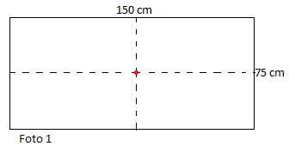

80 cm

**Step 2:**

Take the template, see picture 2 on how to put them together.

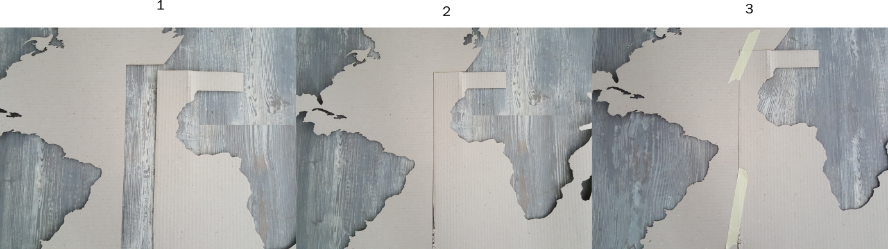**Picture 2**

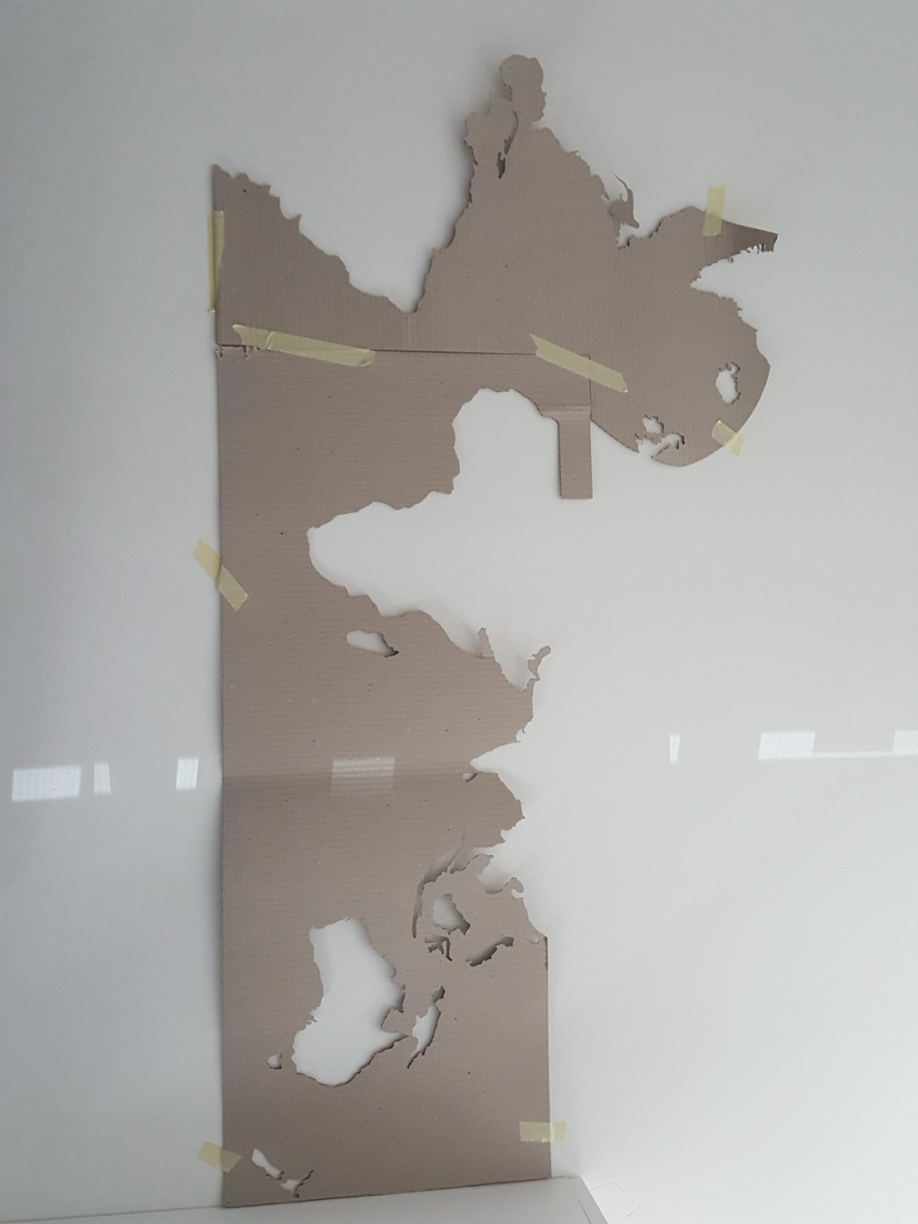**Step 3**The middle point of step 1 should match the arrow in picture 3.

Middle point step 1

**Picture 3**

Place this point on the middle point of step 1 and make sure that the underside of the template is level. You can do this, by using a leveler at the underside.

Stick the template with tape on the wall, so that is keeps hanging **(see picture 3)**

Please read the following page before you start with the steps 4 to 8.

**General information for steps 4 to 8:**

**Please read this before starting with step 4:**

There are 2 ways to apply the 6 big parts:  
- Double sides tape (**important:** don’t forget to remove the white wrap)   
- Kit (**Important:** When you use the kit, always remove the white wrap of the double sided tape. If you do this, you dont have to support the parts.

**TIP**: We recommend using both methods at the same time, so you’re sure of good mounting.

**Apply kit:**

Cut a little corner from the bag with kit, so you can squeze the kit out.

**Work with 1 part at a time, (place the kit as shown below)**

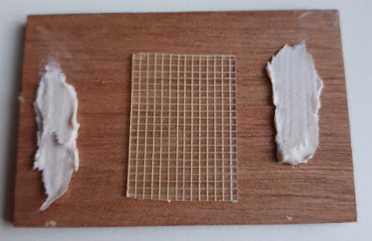

**Make sure you remove the white wrap of the double sides tape.** After this you can put the part on the wall and make sure you push the places where the magnet is on the back (at least 15 seconds).

Sequence: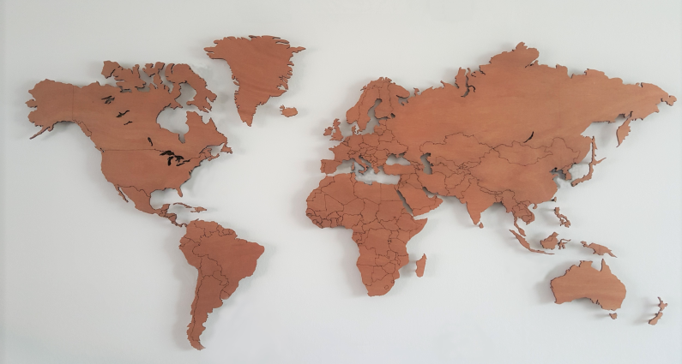

6

1

5

3

4

2

**Applying the big parts**

**TIP:** Do a trial mount **Step 4: Apply continent Africa:**

Start with part 1 (Africa), place it so it matches the template. Please make sure you push the parts after removing the wrap of double sided tape and adding the kit. (15 seconds) (**See Picture 4)**

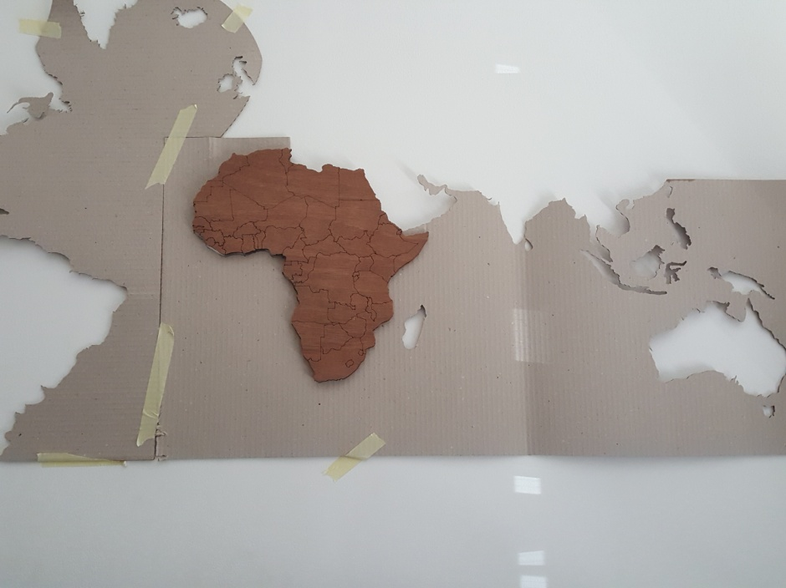 Picture 4

**Step 5: apply Europe/Russia etc.:**

**Important:** Part 1 and 2 matches perfectly in each other **(see picture 5**) and keep in mind that you keep the distance in picture 6.

Place part 2 so it matches the template and keep the above in mind.

Please make sure you push the parts after removing the wrap of double sided tape and adding the kit.

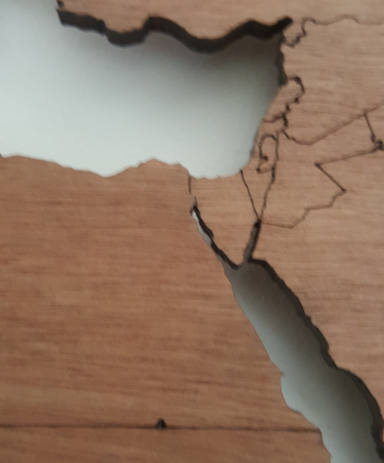picture 5 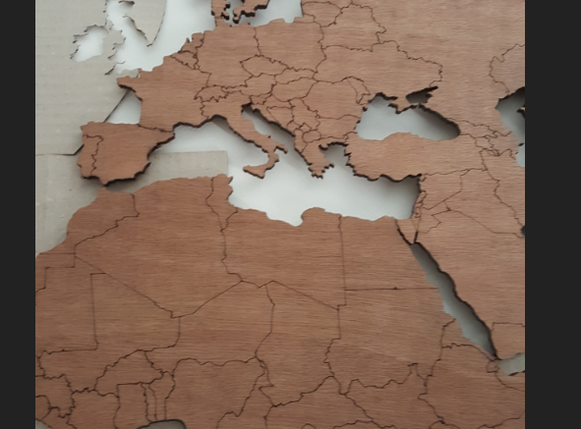 picture 6

**Step 6: North- and South-America:**

Take part 3; place it so it matches the template. Please make sure you push the parts after removing the wrap of double sided tape and adding the kit. (**at least 15 seconds)**

**Important:** Part 3 and 4 fit perfectly in each other **(see picture 7)**

Take part 4; place it so it matches the template. Please make sure you push the parts after removing the wrap of double sided tape and adding the kit. (**at least 15 seconds)**

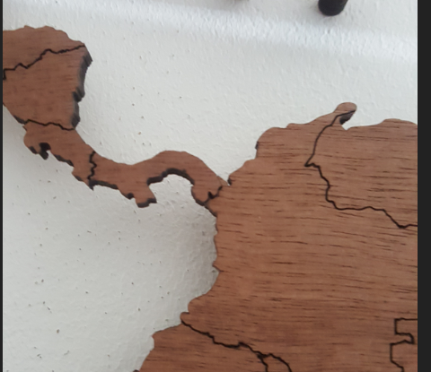 **picture 7**

**Step 7 Geennland en Australia:**

Place part 5 (Greenland) and 6 (Australia) as above.

After finishing the above steps, the world map should look like this:

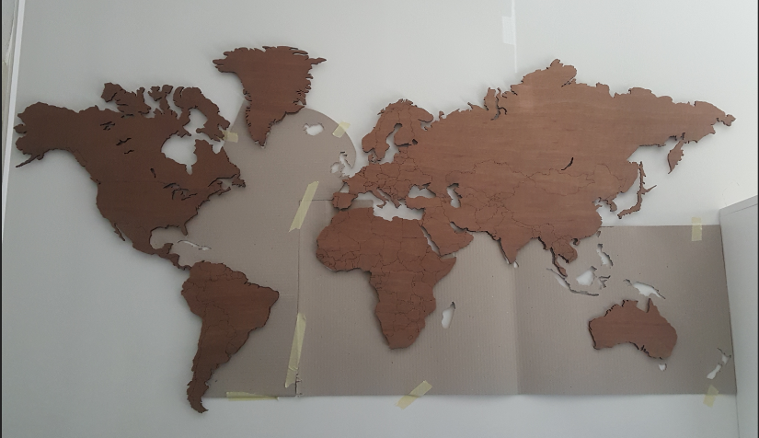

**Stap 8:**

Because it’s magnetic, you can remove the parts en push the plates on the wall. After that you can replace the parts.

**Important: Be carefull when you place the parts back, make sure you do not slam the magnets.**

**Small parts:   
  
Step 9 applying the 17 small parts:  
TIP**: Use hand gloves.

Use the superglue and work fast.

Start with any part you like, after you know where to place the part. Put the superglue on every distance holder. Put the part at the right place and hold it for at least 10 seconds repeat this for every part.

**Important: Before removing the template, make sure the glue is dried. Wait at least 10 minutes before removing the template, see step 9**

**If the superglue is not holding on your wall, use the kit. De dry time is then at least 2 hours before you can remove the template**

This is what it looks like when you’re finished:  
 **Step 9 Removing template:**

**Important:** Make sure everything is dry before removing the template (10 minutes for the superglue and 2 hours for the kit

After everything is dry, you can remove the template by cutting the template towards de different parts.   
 **Important: Don’t try to remove the template in 1 piece. If you do this you risk pulling the parts of the wall.**

After completing the steps, you are done and can enjoy your world map!

**If you have any questions, please let us know.**